A FAIR DEAL IN THE FEDERATION
Albertans are expressing unprecedented levels of frustration with the federal government and the barriers they are imposing on Alberta’s economy. Alberta has been by far the biggest contributing province to Canada. Albertans aren’t asking for a special deal, just a fair one. This is about creating a strong Alberta within Canada.
The Alberta government has announced a Fair Deal Panel to consult with Albertans on a number of issues, including establishing a provincial revenue agency to collect provincial taxes directly by ending the Canada-Alberta Tax Collection Agreement; creating an Alberta Pension Plan by withdrawing from the Canada Pension Plan; and establishing a provincial police force by ending the Alberta Police Service Agreement with the Government of Canada.
The panel will consult with experts, hold open town hall meetings across the province and undertake research to inform their recommendations. All Albertans will be given an opportunity to provide input through online surveys, and other forms of direct feedback.
All Albertans will have the opportunity to provide their input online and through other forms of direct feedback as the panel conducts its public consultations until Jan. 30, 2020. More information on how to participate is available at www.fairdeal.ca.

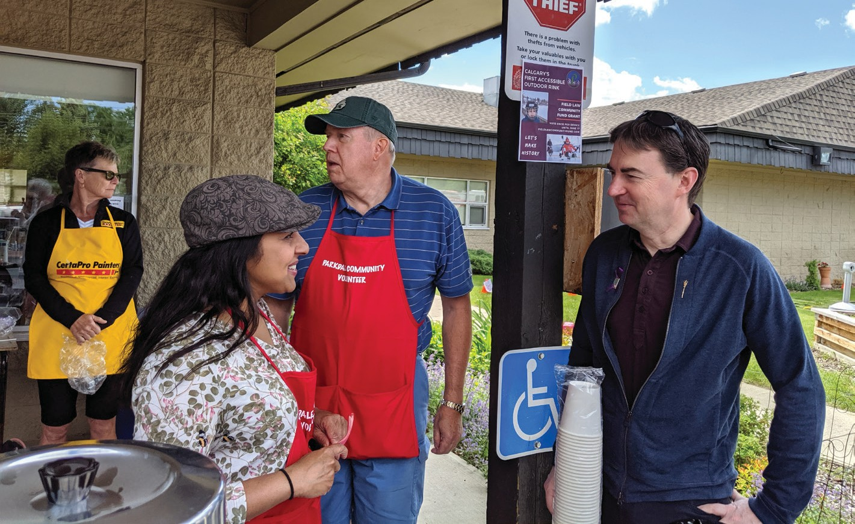
Parkdale Community Association Neighbour Day

CELEBRATORY SCROLLS
Do you know someone celebrating a milestone birthday or anniversary?

celebrating their 65+ birthday, in five-year intervals.
Anniversary scrolls are available to constituents celebrating their 25+ anniversary, in five-year intervals.
Call or email my office if you would like to order a celebratory scroll.

SURVEY SECTION
I want to hear from you. Please take a moment to provide me with feedback. You can go online and answer these questions at https://www.surveymonkey.com/r/ F6N3JHZ or feel free to send me an email or letter with your answers.
- What issue is most important to you?
  - Jobs & Economy
  - Balancing the Budget
  - Health Care
  - Education (K-12)
  - Post-secondary education
  - Other
- Do you feel Alberta has a fair deal from Ottawa?
  - Yes
  - No
- Do you agree with the MacKinnon Report that Alberta has a spending issue?
  - Yes
  - No
- Do you believe Budget 2019 is on the right track to getting Alberta to a Balanced Budget?
  - Strongly agree
  - Agree
  - Not sure
  - Disagree
  - Strongly disagree
- What would you be interested in seeing more of?
  - Morning Coffee Chats
  - Townhall Meetings
  - Constituency Open Houses
  - Attending Community Events
  - Other
- What topic of discussion would you be interested in hearing more about at a townhall meeting?
  - Jobs & Economy
  - Balancing the Budget
  - Health Care
  - Education (K-12)
  - Post-secondary education
  - Other
- Are there any other provincial government issues you would like to raise?
CONSTITUENCY OFFICE
Mailing Address:
201, 1055 20th Avenue NW, Calgary AB T2M 1E7 Phone: 403-216-5436
Fax: 403-216-5432
Email: calgary.varsity@assembly.ab.ca

s we head into 2020 I would like to take a moment to reflect on 2019. We have just come out of a year that has seen many changes. Last spring you trusted me to be your representative for Calgary-Varsity in

JASON COPPING
A Year In Review
Edmonton and I am honoured to represent you. I was also named a member of Premier Kenney’s cabinet as the Minister of Labour and Immigration. I have taken both responsibilities seriously and immediately rolled up my sleeves to get to work on issues that matter most to Albertans.
A
Our riding of Calgary-Varsity is unique in that many residents not only live here, but also work here; whether it be at the University, one of our many great schools, Foothills Campus or the Alberta Children’s Hospital. In order to represent your interests in Edmonton, I am happy that I have been able to meet with many of you either in my office, at one of our coffee chats, our townhall, or through meeting with many stakeholders. I have also heard from many constituents via email and phone calls. The message I continue to hear is that jobs, the economy, health care, and education are top priorities while, at the same time, ensuring Alberta’s budget is responsibly managed. Thank you for your passion and engagement. By hearing from you, I can best represent our interests.
The legislative sessions both last spring and this past fall have been robust. I am proud that I could support legislation such as the Carbon Tax Repeal Act, the Job Creation Tax Cut, the Red Tape Reduction Act and the Open for Business Act. All of these measures have lifted barriers to job creators making it easier to attract investment back to Alberta.
Supporting legislation such as the Disclosure to Protect Against Domestic Violence (Clare’s Law) Act, is a positive step in protecting those at risk of experiencing domestic violence or facing abuse. In addition, moving forward with a review of the Tobacco Act to specifically address vaping is critical in protecting our youth.
I also fully support the additional funding to support mental health. The government is investing $140 million over four years to improve the mental health and addiction services, including an investment of $22 million to deliver more mental health supports for post-secondary students.
These are just a few examples of the work being done in Edmonton. I look forward to the challenging work we need to do over the coming year to continue to bring investment to Alberta, protect the vulnerable, and ensure Albertans have the tools they need to be prosperous.
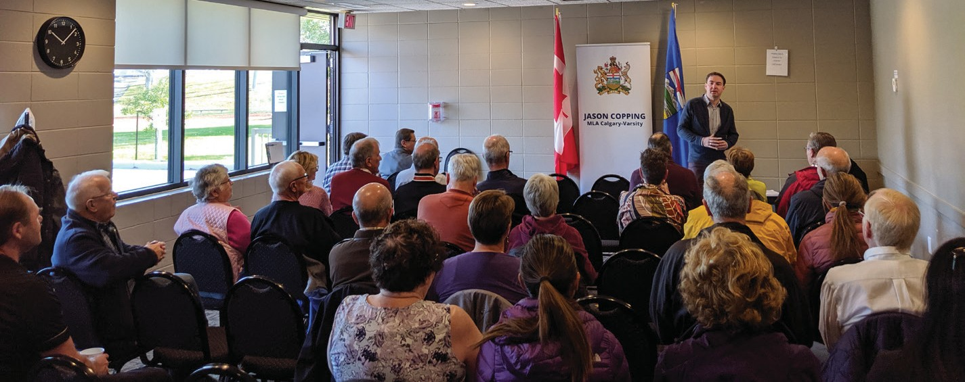
Townhall at Silver Springs Community Centre

BUDGET 2019
One of the Alberta government’s first priorities was to review the current fiscal situation to bring Alberta back to a balanced budget. This past summer the MacKinnon report (https://www.alberta.ca/mackinnon-report-on-finances.aspx) clearly showed us that Alberta has a critical and long-standing over-spending problem. In fact, Alberta spends more per person on services than the three largest provinces, but we are not seeing better results for our investment. The MacKinnon report was thoroughly reviewed and helped shape the budget.
Budget 2019 is a balanced plan aimed to create jobs, grow the economy and protect our vital services such as health care and education. With a moderate reduction of 2.8 per cent over four years we are in line with the MacKinnon report recommendations and extensive consultations. Budget 2019 also increased funding to health care by $200 million and maintained funding for

IN THE LEGISLATURE
As a member of government, I have the privilege to work on legislation that will benefit all of Alberta. One initiative that falls under the Labour and Immigration portfolio that I have been proud to work on is the Alberta Advantage Immigration Strategy. This strategy will focus on economic immigration and will help guide how immigration can help grow our economy by bringing in skilled newcomers to support the province’s workforce, create jobs in the labour market and ensure newcomers can fully use their skills and integrate successfully into their communities for the benefit of all Albertans.
TIER
This past session, the Alberta government also announced its plan on the

RED TAPE REDUCTION UPDATE
Unnecessary red tape stifles economic growth and in a time when we need to get our job creators and innovators back to creating jobs, I was pleased to see that Bill 25, the Red Tape Reduction Implementation Act pass (https:// www.alberta.ca/red-tape-reduction-implementation-act.aspx) This Act will speed up regulatory approvals, reduce burdens for municipalities and government partners, and eliminate outdated rules.
Over the next four years, red tape reduction across government, combined with streamlined process and consolidating administrative services, is expected to save at least $140 million.
I would like to thank those of you I have met with and who have submitted ideas to further reduce red tape. Suggestions about where government can cut even more red tape can be shared at CutRedTape.Alberta.ca.

K-12 education.
This budget is a commitment to live within our means, ending overspending and eliminating the deficit, all while maintaining the critical services on which we rely.
While we recognize that spending restraint is difficult, we need to act now to ensure the long-term sustainability of our programs.

environment. I am pleased to see the Technology Innovation and Emissions
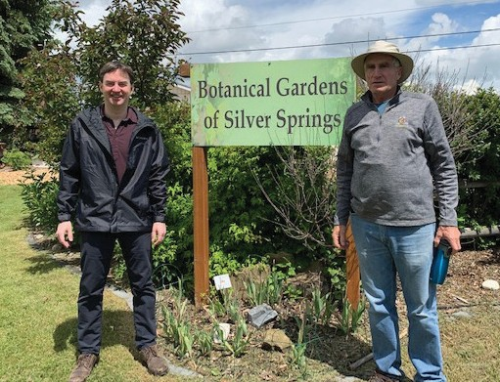
Reduction (TIER) Implementation Act was passed in the legislature. TIER is a realistic approach to addressing climate change that will reduce emissions and restore certainty for investors and industry.
TIER is an improved system to help energy-intensive facilities find innovative ways to reduce emissions and invest in clean technology to stay competitive and save money. TIER is a unique solution that allows the province to reduce emissions.
TIER requires electricity generators to meet a “good-as-best-gas” benchmark, where their emissions are equal to the cleanest natural gas-fired generation

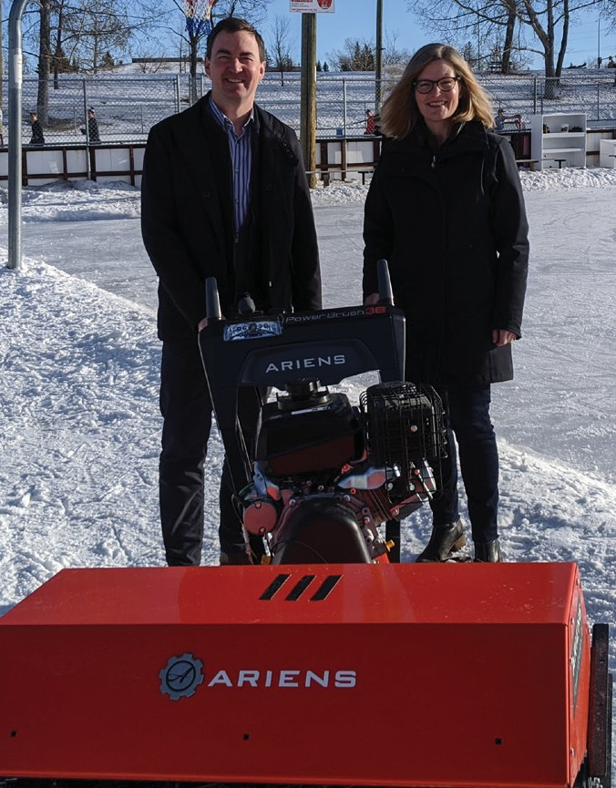
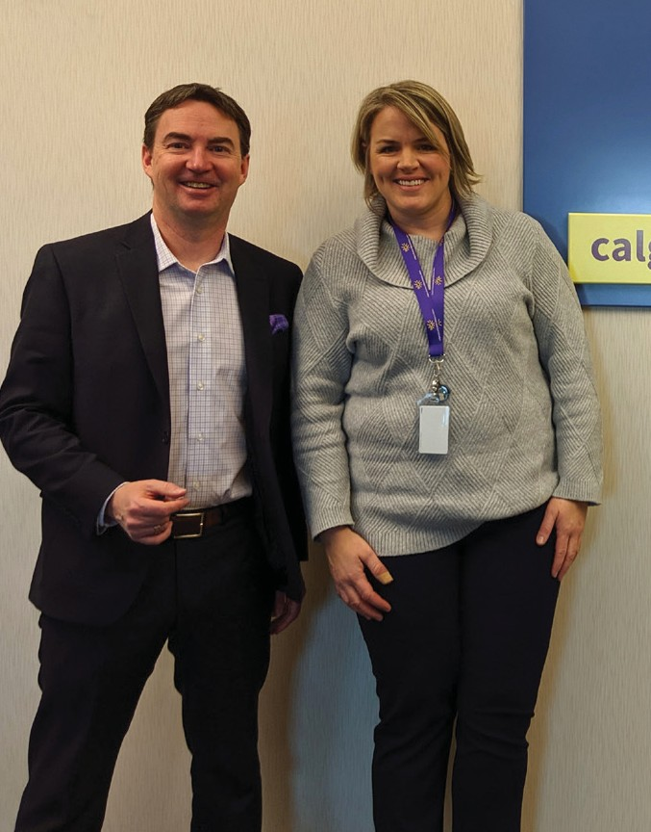
Silver Springs Community Association Calgary & Area Child Advocacy Centre
Making a difference:
- Carbon Tax Repeal Act
- Job Creation Tax Cut reducing the business tax rate to eight per cent
- Red Tape Reduction Act
- Disclosure to Protect Against Domestic Violence Act (Clare’s Law)
- Technology Innovation and Emissions Reduction Implementation Act
- Fair Registration Practices Act
plant. All other facilities that emit more than 100,000 tonnes of carbon dioxide must reduce their emissions by 10 per cent in 2020. Facilities will need to reduce emissions by an additional one per cent every year after 2020.
For more information go to https://www.alberta.ca/technology-innovation-and- emissions-reduction-engagement.aspx

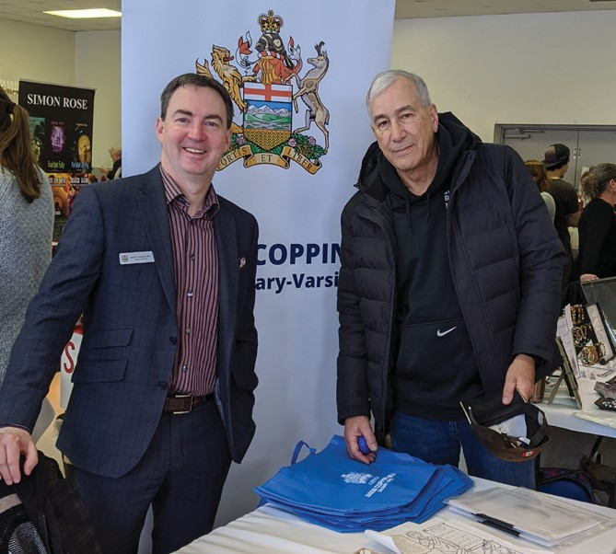
Coffee and Chat at Lazy Loaf Triwood Christmas Market
University of Calgary Clubs’ Week Silver Springs Botanical Gardens
Manor Town Hall Meeting

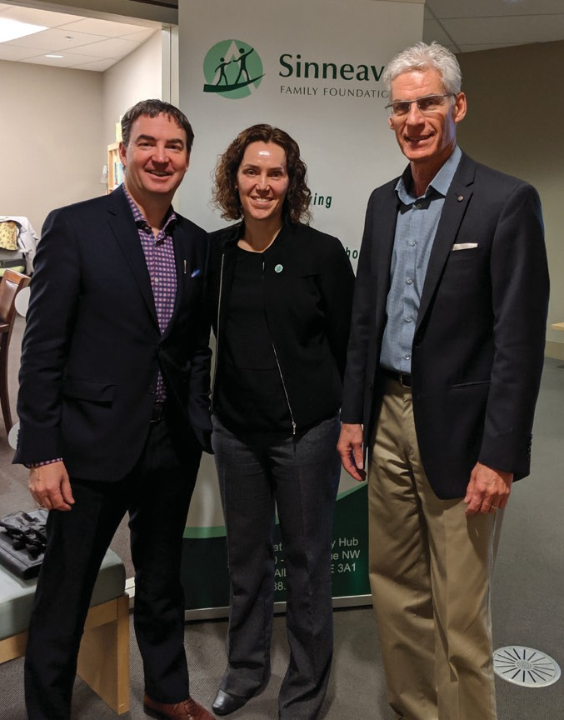
Sinneave Family Foundation
University of Calgary Students’ Union
Tour of Foothills Campus Cancer Centre

